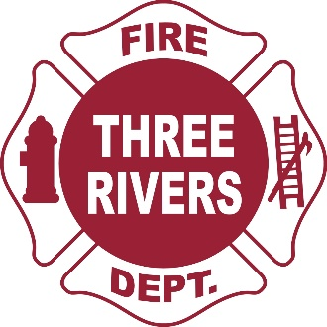 | Three Rivers Fire Department  333 W. Michigan Avenue  Three Rivers, MI 49093  269-278-3755  Fax: 269-278-6808  www.threeriversmi.org

Due to warm and abnormally dry conditions, Three Rivers Fire Department is issuing a burn ban for the City of Three Rivers and Lockport Township. The ban will remain in effect until further notice.

This burn ban covers any open burning including campfires, yard waste and any household waste.

Please contact Three Rivers Fire department with any questions.

USDA Forest Service currently has most of Michigan under extreme and very high fire danger level:

Fire Danger Level: EXTREME
When the fire danger is "Extreme," fires of all types start quickly and burn intensely. All fires are potentially serious and can spread very quickly with intense burning. Small fires become big fires much faster than at the "Very High" level. Spot fires are probable, with long-distance spotting likely. These fires are very difficult to fight and may become very dangerous and often last for several days or weeks.
Fire Danger Level: VERY HIGH
When the fire danger is "Very High," fires will start easily from most causes. The fires will spread rapidly and have a quick increase in intensity, right after ignition. Small fires can quickly become large fires and exhibit extreme fire intensity, such as long-distance spotting and fire whirls. These fires can be difficult to control and will often become much larger and longer-lasting fires.

