Centreville Fire Chief’s Report:
We had 13 calls for the month of April
Nottawa had 6 calls
- 4-11 Londick Rd Personal injury accident
- 4-11 Findley Rd Trees on fire
- 4-15 25266 Truckenmiler Rd Assist to Lifecare full arrest
- 4-19 m-66/m-86 Personal injury accident cancelled in route
- 4-22 Riverside Dr./ Angevine Rd. Tree limb in lines
- 4-26 60221 Nottawa Rd. Personal injury accident truck vs tractor
Village had 3 calls
- 4-10 658 E. Main St. smell of burnt plastic
- 4-26 341 W. Charlotte CO2 alarm
- 4-30 225 W. Burr Oak St. CO2 alarm
Lockport had 1 call
- 4-30 Schwietzer/ Covered Bridge Personal injury accident ended up being fishermen in a boat
We had 2 Mutual aid calls and 1 Automatic aid call
- 4-9 71222 Shimmel Rd. Assist station 6 field fire
- 4-10 63740 Balk Rd. put on standby by station 6 for a structure fire
- 4-25 200 E. Broadway Automatic aid to station 2 canceled in route

Three Rivers Library Report:
Report on Three Rivers Public Library Board Meeting held on May 23, 2023
- The library hours of operation remain 10 a.m. to 5:30 p.m. Monday-Friday and 10 a.m. to 4 p.m. on Saturday (Note: They will close at 3 p.m. on June 14 for staff training and at 4 p.m. on June 15 to participate in the Water Festival Parade.);
- There are currently 1,316 Lockport Township residents registered with the Three Rivers Library;
- The traveling Smithsonian Exhibit is scheduled to be at the library from July 8 through August 19. Many events and activities will be featured throughout the community, including the history of townships; this free event is open to the public during library hours of operation;
- Summer Reading Program is now open for enrollment. The program runs from June 17 – August 12;
- Here are some of the activities currently being offered at the library (be sure to check with the library to see if you need to register for event):
- Story time for preschoolers, book clubs for all ages, Cardio Drumming, Knitting/Crochet Club, an Adult Walk & Talk Program, and Adult Spark Wellness Support Groups.
- A Book Sale is scheduled for June 17 from 10 a.m. – 2 p.m.
- June 20: Chip Taste Test, 2-3 p.m.
- June 21: Coffee & Conversation - 11:30 – 12:30; The Lost Art of Pen Pals - 1-2 p.m.; Teen Summer Fun - 4-5 p.m.;
- Check their website at info@threeriverslibrary.org or call 269/273-8666 for further questions, details on activities, or to be added to the Newsletter List;
- Next board meeting will be held at the library on Tuesday, June 13, 2023, at 6:00 p.m.

Submitted by Charlene Zavala

Nottawa Library Report:
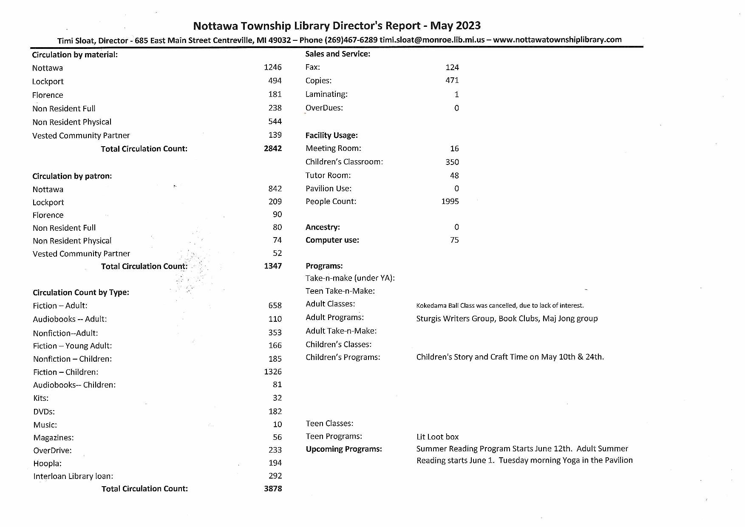
Website Report:
If you have any questions, please contact Mark or Melissa.

Water Board Report:
LOCKPORT TOWNSHIP WATER BOARD MEETING MINUTES
June 6, 2023
Purpose of the meeting: Regular meeting of the Lockport Township Water Board.

Members Present:
Joe Nowicki, Chairman
Mark Major, Board Member
Glenn Wegner, Board Member
Carey Williams, Operator
Annie Signorello, Billing Clerk

Members Absent:
Lee Ross, Board Member
Becky Myers, Board Member

Call to Order:
The June 6, 2023 meeting was called to order by Joe Nowicki at 5:00 p.m. Roll call: Joe, Mark, Glenn, Carey, Annie.

Board Members Absent: Lee Ross & Becky Myers

Agenda Approval:
Glenn motioned to approve Agenda as presented. Mark seconded the motion. ROLL CALL: Joe-Yes, Mark-Yes, Glenn-Yes. MOTION CARRIED 3-0

Meeting Minutes Approval:
- Mark motioned to amend the regular meeting minutes of May 4, 2023, to include “G” under Accountants Report, to have Mike Friesner close Flagstar Checking Account and deposit funds into Flagstar Savings Account. Joe 2nd Motion. ROLL CALL: Mark-yes, Joe-yes, Glenn-yes. MOTION CARRIED: 3-0

Visitors Comments:
None

System Operators Report:
- Carey discussed pump usage, Well #2: 2,809,529 gallons and Well #3: 2,884,000 gallons. Total usage 5,693,529 gallons for May.
- 131 hydrants flushed.
- 2 hydrants in need of repair, Location: Buckhorn Rd. & Fisher St. Carey will contact Adam w/Perceptives to see when he can get work completed.
- Consumer Confidence Report (CCR) available. Annie to post ad in newspaper and place information on June bills. CCR posted on Township Website on June 6, 2023.
- A few Miss Digg requests. Locations: Wilbur Rd and US 131 area.
- Discussion on Work Orders.

Inventory:

- 8 Meters; 33 MXU’s in Inventory
- Nothing to report for June meeting.

Budget:
- Mark motioned to approve Budget as presented and present to Lockport Township Board. Joe 2nd Motion. ROLL CALL: Mark-yes, Joe-yes, Glenn-yes. MOTION CARRIED 3-0.

Accountants Report
- Accounts Receivables: May deposits $ 21,706.07
- Accounts payable for the month of May 2023, were presented. Discussion: Mark motioned to pay May bills in the amount of $10,883.91. Joe 2nd motion. ROLL CALL: Joe-yes, Mark-Yes, Glenn-Yes. MOTION CARRIED 3-0.
- Bank balances for the month ending May, 2023 were discussed.
- System Operations Summary for the month of May, 2023. discussed as presented.
- Cubic Feet of Water: Discussed as presented.
- No Correspondence for the month of May, 2023.

Old Business:
- HydroCorp: Corporate Plan- 2 year contract with a minimum of 13 inspections a year, (total of 26 per contract). Total contract amount $6,144.00. Discussion on insurance clause. Mark motioned to hire HydroCorp for a 2 year contract, to inspect possible cross connections on commercial properties, for a total contract price of $6,144.00. Joe 2nd motion. ROLL CALL: Mark-yes, Joe-yes, Glenn-yes. MOTION CARRIED: 3-0
- Discussion on Grant Writing.

New Business:
Board Roles: Joe appointed Lee Ross as Treasurer. Glenn to continue working on Inventory and Assest Management.

Shelfing units to be purchased for Well House #2.

Adjournment:
Glenn made a motion to adjourn the meeting at 6:39 p.m. Mark seconded the motion. All in favor. MOTION CARRIED 3-0.

Respectfully Submitted,
/s/
Annie Signorello
Secretary

Next scheduled regular meeting Thursday, July 6, 2023, 5:00 pm, due to Holiday.

Government Relations Report:
Government Relations Committee: – met on June 6th.
Three Rivers Health – reported OR renovations underway with completion expected in Mid-July, construction will take place at the fitness center on the changing rooms and working on the sauna and whirlpool and parking lots, working on the 2024 capital budget, ordered a new CT scanner and new bone density scanner, working on a comprehensive financial recovery plan.
St. Joseph County – will hold a ground breaking for the Family Courts building in Three Rivers
Centreville – the code enforcer will receive a raise, new fuel tanks will be installed in the Village, the Little League field is making improvements, they are having trouble with the sewer system and lagoons, doing land division parcels in the industrial park, studying the water system, they will hold their Community Gathering in August for the businesses.
Lockport Township – had the May election audited, working on the implementation of Proposal 2, working on budget
Park Township – the sewer study is moving along, still working on zoning with emotional support chickens, Mercury Broadband is not fulfilling broadband plans, township is considering next steps, just finished Marcellus Rd. construction.

Planning Commission Report:
May 23, 2023 Planning meeting, by Mike Friesner
Susdorff Rezoning request passed after discussion (Farm Land Split on corner of Buckhorn and Edgerton).
Lovers Lane Rezoning request passed after discussion (Retail Commercial to Single Family Residential North West Corner of Lovers Lane and Silvertone Dr.)
Established and passed
Tiny Home Overlay District and adjusted Text Amendments 95.112, 95.404, and 95.504 for House size and Lot size. Also discussed teaming up with St. Joseph County Veterans Affairs.
Master Plan Update and New Books discussion.
New Zoning Maps discussion.

Cash Reports:
BANK BALANCE
31-May-23

BEGINNING BALANCE SMB GENERAL CHECKING #5598 $7,511.42
DEPOSITS/CREDITS $27,635.64
CHECKS/DEBITS $27,545.08
SUB TOTAL $7,601.98
OUTSTANDING CHECKS $6,401.15
OUTSTANDING DEPOSITS $0.00
ADJUSTED CHECKING BALANCE $1,200.83

TRANSFERS FROM GEN SAVS#2470 TO GEN CKG#5598 $44,429.17
CHECKS DRAWN 06/12/2023 $44,429.17
CHECKING BALANCE TO DATE $1,200.83

BALANCE OF ACCOUNTS TO DATE:

GENERAL CHECKING BALANCE #5598 $1,200.83

SOUTHERN MICHIGAN BANK GENERAL SAVINGS #2470
(Includes $61,250 FIRE TRUCK FUND) $511,363.22
(Includes $12,530.98 in Inspections/Building Fund)

ARBOR CU #659
ARBOR CU #659 $100,111.76

HORIZON BANK CD#1643 (4-12-24) $188,506.28

HORIZON BANK SAVINGS #7914 $17,275.50

KALAMAZOO COUNTY STATE BANK CKG #1518 "ARPA" $369,687.78

KELLOGG COMM FED CU CD#9300 (02-03-25) $82,747.68

KELLOGG COMM FED CU SAVINGS $5.00

OMNI CU MONEY MARKET# 1540 $242,136.99

OMNI CU SAVINGS#1540 $1,446.18

SOUTHERN MICHIGAN BANK CD#5608 (06-16-23) $52,742.51

SOUTHERN MICHIGAN BANK ESCROW #2468 $3,214.99

THREE RIVERS BANKING CD#5669 (01-13-25) $121,838.03

TOTAL CASH ACCOUNTS: $1,692,276.75

TREASURER'S TAX PETTY CASH ON HAND: $100.00

2021-2022 TAX CHECKING #2819 & SAVINGS #5614 ACCTS SUMMARY
Balance Forward Tax Accounts: $307,307.46
Plus Tax Deposits #2819 05/09/23-06/12/23 $0.00
Minus Service Chgs #2819 & #5614 $0.00
Plus Interest #2819 & #5614/or NSF fees paid $299.95
Plus Voided Checks/adjustments $0.00
Minus NSF/reversals etc. $0.00
Minus Pmts/transfers made #2819 05/09/23-6/12/23 $307,396.44
TOTAL COMBINED TAX ACCOUNTS AS OF 06/12/2023 $210.97

Regular Meeting Minutes:
LOCKPORT TOWNSHIP REGULAR MEETING
58982 Holtom Rd. Three Rivers, MI
May 8, 2023

Members Present: Mark Major, Mike Friesner, Donna Grubbs & Rick Daniels.
Also present: Dale Hutson, Elena Meadows & Beccy Friesner.

Members Absent: Christy Trammell

Call to Order: The meeting was called to order by Supervisor Major at 6:00 p.m.

Approval of Agenda: Daniels made a motion to accept the agenda. Grubbs seconded the motion. Motion carried 4-0.

Approval of the Consent Agenda: Friesner made a motion to accept the consent agenda which included: Centreville Fire Chief’s Report for March; April 25, 2023 Three Rivers Library Board Meeting Minutes; May 4, 2023 Water Board Meeting Minutes; Website Report; April 10, 2023 Regular Meeting Minutes; April 10, 2023 Election Commission Meeting Minutes. Grubbs seconded the motion. Motion carried 4-0.

Public Comments:
- Keith Wilson, 58773 Pine Trail, inquired about the status of changing the survey line. Hutson reported that title company owner Garrett McNally could work with surveyor Mostrom to identify the correct legal description for each property, then the title company would create affidavits indicating the problem and the correct legal description. This process would cost about $10,000, but the township attorney could not guarantee other title companies would not have issues with this solution. Board members felt a supervisors’ plat, though possibly costing $30,000, would offer the residents a better guarantee. Hutson will have an attorney go out for bid on a supervisors’ plat and send an informational letter to Pine Trail residents inviting them to the July meeting for more discussion.
- Lynn McLeod, 1631 Nixon Lane, discussed Frontier poles, election inspectors, Section 8 housing in the city, whether Coolidge was a city street, and document sharing between municipalities.
- Charlene Zavala, 16916 Bridgette Drive, asked about the city’s boundary lines.
- Mary Shirk, 58536 Ash Road, thanked the township for fixing her road.
- Gloria Johnson, 19130 S. River Road, spoke about open meetings.

Enforcement Officer’s Report: None.

Assessor’s Report: Pine Trail, the only item in Hutson’s report, was discussed above.

Treasurer’s Report and Bills: Friesner reviewed the Treasurer’s Report. Major made a motion to accept the report, pay the bills and file the report. Daniels seconded. Motion passed 4-0. Friesner noted that the township had a Certificate of Deposit coming due at Southern Michigan Bank & Trust on June 16, 2023 and recommended we renew it for 21 months at approximately 4.10%. If the township finds a better rate, it will take the penalty and move the money into the higher rate CD. Daniels made a motion to approve Friesner’s recommendation and Grubbs seconded it. Motion passed 4-0 with a roll call vote. Beccy Friesner asked if the township had an investment policy; Mike Friesner said this was usually done by larger townships and his policy was to give the board options and have members vote. Daniels said he thought the township was doing fine as is.

Committee Reports:
- Government Relations – Daniels said he would like to discuss the township leaving the government relations committee, but wanted Trammell to be present for that discussion.
- ZBA – The next meeting is set for May 30, 2023 at 7:00 p.m. Fritz Pins, the ZBA alternate, has moved up to a full member following the passing of Paul Miller. Loren Bellinger has volunteered to be an alternate. Major made a motion to approve Bellinger as a ZBA alternate; Grubbs seconded it. Motion passed 4-0 with a roll call vote. Grubbs said she would be taking ZBA classes.
- Elections – Everything balanced at the close of the polls and the workers were done by 9:30 p.m.
- Nottawa Library – Their meeting was postponed to June due to lack of a quorum; the library had 370 visitors from Lockport Township.
- Centreville Fire Board – The fire truck should be here in two to three months. Major was pleased to report that 70-80% of the truck was Michigan made.
- Planning – A public hearing will be held May 23, 2023 for several items: tiny homes, rezonings, and text amendments.
- Three Rivers Library – report was included in Consent Agenda. Township representative Charlene Zavala made special mention of the Smithsonian exhibit coming to the library from July 8 to August 19. Three Rivers is one of only six libraries in Michigan to host it.
- Water Department – report was included in Consent Agenda.
- Website – report was included in Consent Agenda.
- Building Committee – Grubbs reported that Trammell was following up with Shawn Heivilin.
- Roads Committee – Ash Road is paved; Lutz Road will not be widened until the end of September in order not to disturb a group of nesting warblers.
- ARPA Funds Committee – Funds can be used for water, sewer, broadband, and roads. All funds must be earmarked by 12/31/2024, spent by 12/31/2026, and the last report submitted by 4/30/2027. Work completed must be in accordance with the Davis-Bacon Act. So far, the township has only used $21,000 of the money, for a speaker system, new chairs, and new office furniture.
- Water & Sewer Committee – The next meeting is set for May 24, 2023.

Old Business: The township has received three estimates from potential new accounting firms; a decision will be made at the annual meeting.

New Business: Friesner made a motion to make Fahey Schultz Burzych Rhodes PLC the lead law firm for the PA 425 with Park Township, include them in looking into the matter of Section 8 housing in the city, and consult with them about the township’s existing PA 425s. Daniels supported the motion, which passed 4-0 with a roll call vote.

Adjournment: Daniels made a motion to adjourn the meeting at 8:20 p.m. Grubbs seconded the motion. Motion carried 4-0.

A budget work session will be held May 22, 2023 at 5:00 p.m.

The next regularly scheduled meeting is June 12, 2023.

Respectfully Submitted,

Elena Meadows
Deputy Clerk

Budget Workshop Session Minutes:
LOCKPORT TOWNSHIP BUDGET WORKSHOP
Lockport Township Hall
May 22, 2023 5:00pm

Members Present: Mark Major, Mike Friesner, Christy Trammell, Rick Daniels & Donna Grubbs.
Also present: Beccy Friesner & Elena Meadows.

Members Absent: None

Call to order: The meeting was called to order by Supervisor Major at 5:00 p.m.

The board went through previous budgets line by line to become familiar with the budget. Items were discussed that may occur in the next fiscal year. A public hearing was set for the budget at the next regularly scheduled meeting.

The next regular scheduled meeting is June 12, 2023.

Respectfully Submitted,

Christy Trammell
Township Clerk

Annual Meeting Agenda:
Lockport Township
Annual Meeting Agenda
June 12, 2023
I. Call to Order/Pledge of Allegiance
II. Approval of Agenda
III. Approval of Annual Meeting Minutes of June 13, 2022
IV. Public Comment
V. 2023/2024 Budget
VI. Establish Meeting Dates-Second Monday of Month
VII. Establish Depositories
a. Southern Michigan Bank
b. Horizon Bank
c. Kellogg Comm. Fed. CU
d. Three Rivers Banking Center
e. Arbor Credit Union
f. Huntington Bank
g. Omni Credit Union
h. Kalamazoo County State Bank
i. Century Bank and Trust
VIII. Appointments to Boards
a. Planning Commission
i. Kelli Atkinson- 3yr term 2023/2026
ii. LouElla Hamilton- 3yr term 2023/2026
b. Zoning Board of Appeals
c. Water Board
i. Joe Nowicki – 3yr term 2023/2026
ii. Mark Major -3yr term 2023/2026
d. Building Inspectors. Joe Wickey, Ron Bellaire, John Dobberteen- 1yr term 2023-2024
e. Enforcement Officer. Doug Kuhlman 1yr term 2023-2024
Mike Haydon 1yr term 2023-2024
f. Township Attorney. Roxanne Seeber 1yr term 2023-2024
g. Zoning Administrator. Doug Kuhlman 1yr term 2023-2024
IX. Accountant. Locey Cpa 1yr term 2023-2024 X. Water Department Budget 2023/2024
XI. Dump Passess 2023/2024
Adjournment
Next annual meeting June 10, 2024

Regular Meeting Agenda:
Lockport Township
Agenda
June 12,2023
Regular Meeting
I. Call to Order Mark Major
II. Approval of Agenda
III. Approval of Consent Agenda
Including: Treasurers Cash Statement, Three Rivers Library Report, Nottawa library Report, May 8, 2023 Regular Meeting Minutes, Budget Worksession Minutes for May 22, Water Board Report, Centreville Fire Chiefs Report for April 2023, Web Site Report, Government Relations and Planning Commission Meeting for May 23.
IV. Public Comments
V. Enforcement Officer Doug Kuhlman
VI. Assessors Report Dale Hutson
VII. Treasurers Report and Bills Mike Friesner
VIII. Committee Reports
a. Government Relations Rick Daniels
b. ZBA Donna Grubbs
c. Elections Christy Trammell
d. Nottawa Library Mike Friesner
e. Centreville Fire Board Mark Major
f. Planning Mike Friesner
g. Three Rivers Library Char Zavalia
h. Water Department Mark Major
i. Website Melissa Major
j. Building Committee Christy Trammell, Donna Grubbs k. Roads Committee Mark Major, Mike Friesner
l. ARPA Funds Committee Christy Trammell, Mike Friesner m. Water & Sewer Committee Mike Friesner, Rick Danials
IX. Old Business
X. New Business
Adjournment

